Friday, 22 March 2024

**Multithreading, Concurrency & Parallel programming**

**Why we even need multiple, both threads**.

The two main reasons we need threads for -

* Responsiveness
* Performance

**Responsivness**

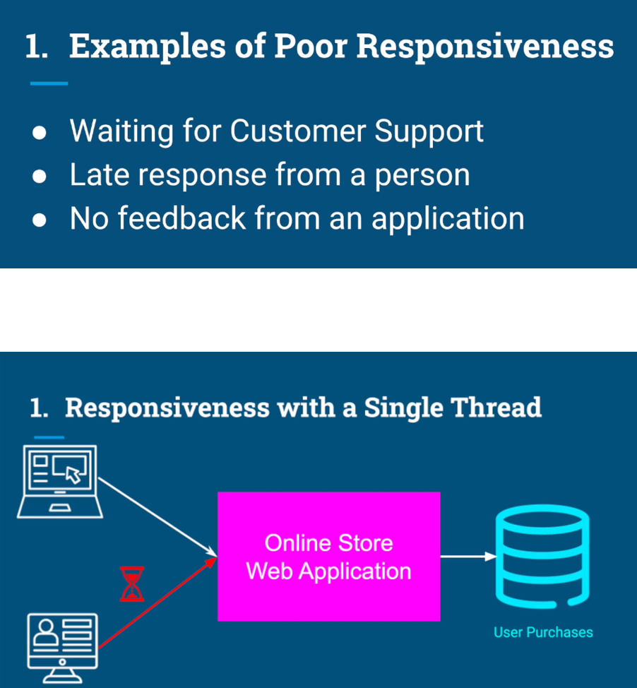

With multithreading we could actually serve multiple users simultaneously, but serving each request on a different thread.

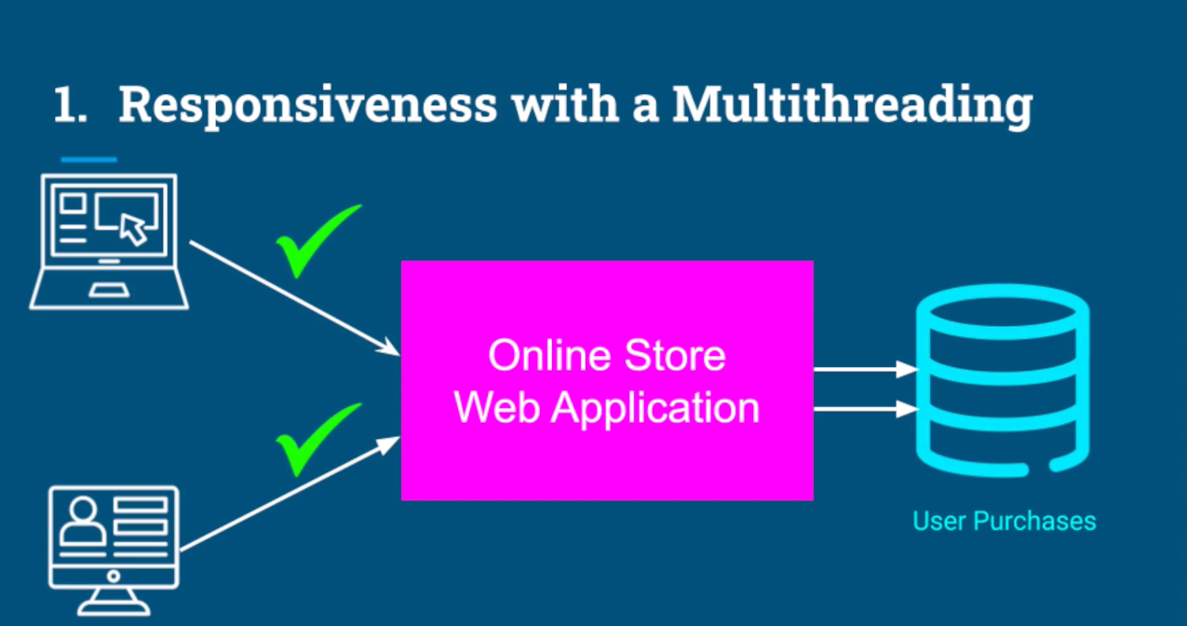

Responsiveness is particularly critical when it comes to applications with a user interface. A good example for that can be a movie player application.

The application is showing us images, blamed the audio.

And in the same time, we expect that if we move the mouse or click

a button, we would get an instant feedback for our actions on the screen.

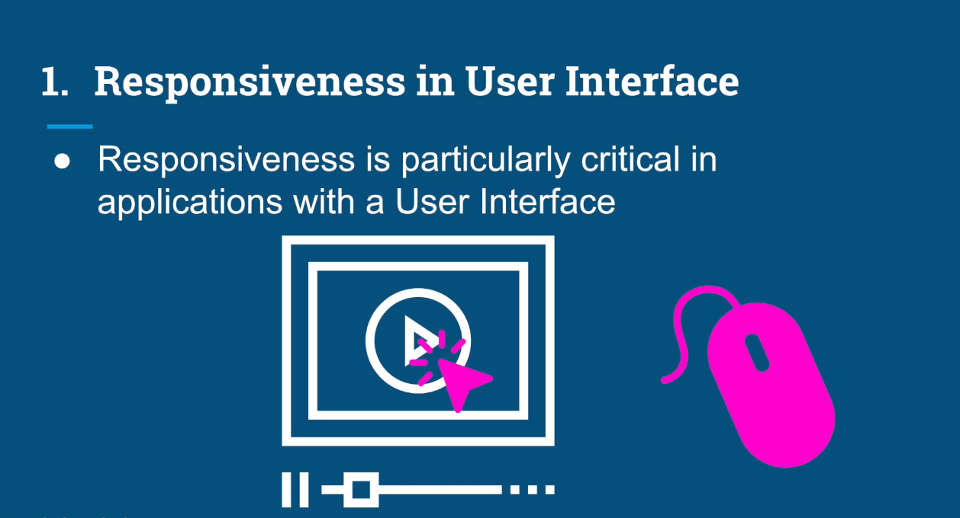

This kind of responsiveness can be achieved by using multiple threads,

each thread for a different task.

By multitasking quickly between different threads, Our computer can create an illusion that all those tasks are actually happening in the same time.

The term we use for this kind of multitasking is concurrency.

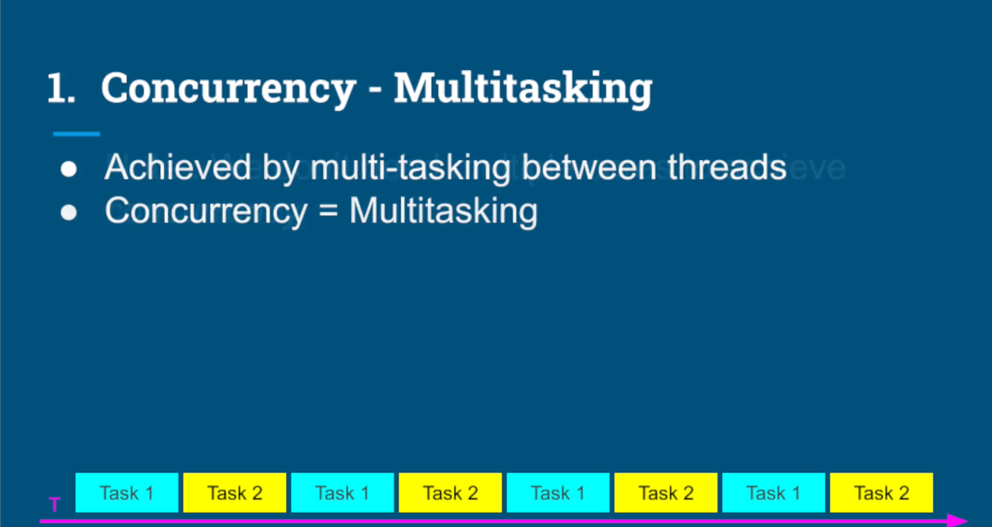

we don't even need multiple cores to achieve concurrency. Even with one core, we can create responsive applications by using multiple threads.

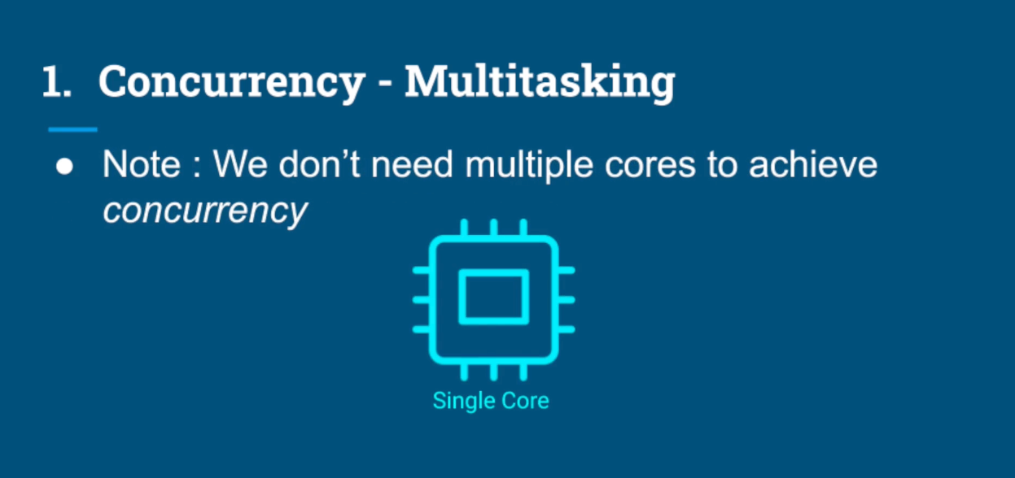

**Performance**

As mentioned before using concurrency, we can create an illusion of multiple

tasks running in parallel just with single core. With multiple core we can truly run multiple tasks completely in parallel.

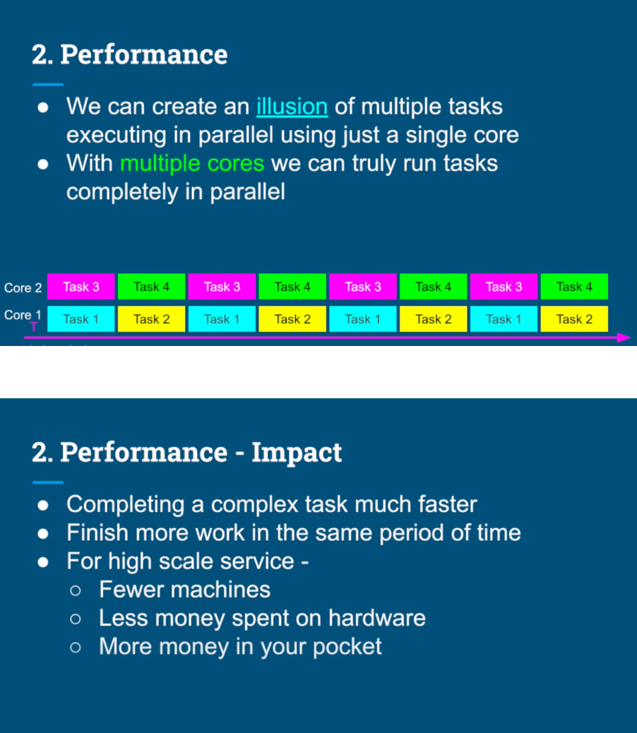

Responsiveness - Concurrency

﻿Performance - Parallelism

#### What threads are and where they live

When we turn on our computer a special program called the operating system is loaded from the disc into the memory.

The operating system takes over and provides an obstruction for us.

The application developers, and helps us interact with the hardware and the CPU. So we can focus on developing our apps.

All our applications, such as the text editor, a web browser, or a

music player reside on a disc in a form of a file, just like any Other

music file image or document when they user runs an application, the

operating system takes the program from the disc and creates an instance

of that application in the memory.

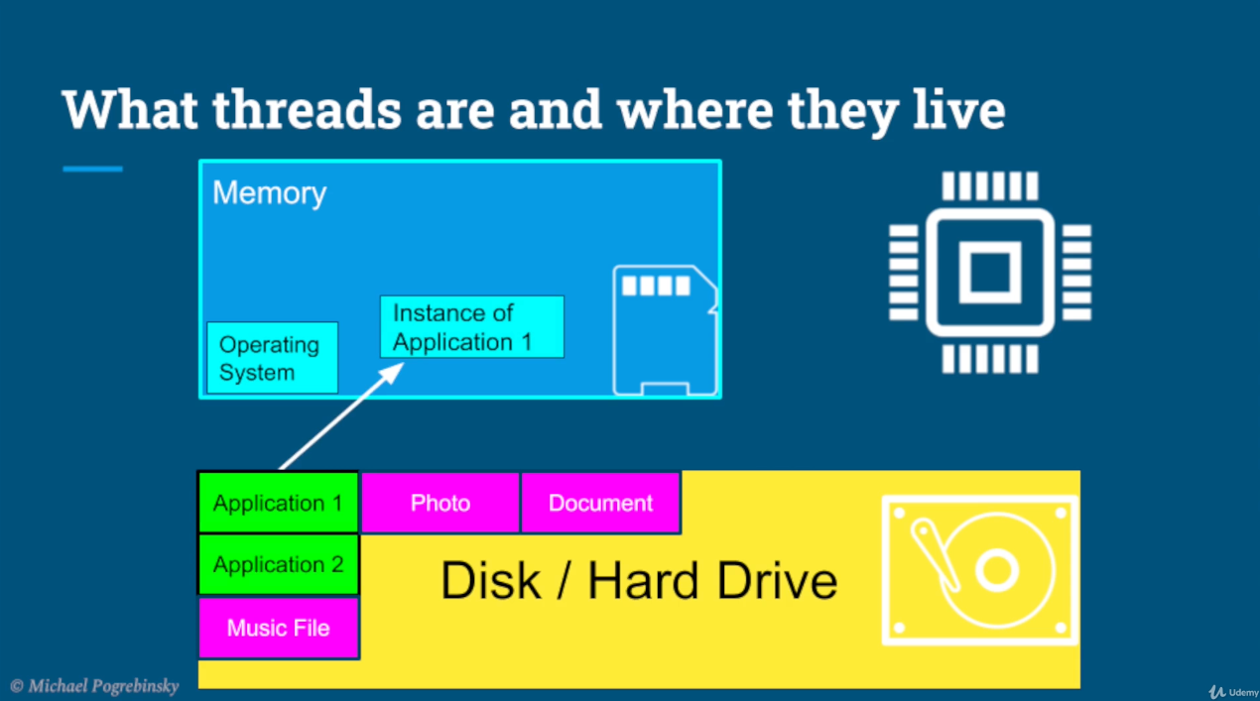

That instance is called a process, and it's also sometimes called

a context of an application.

Each process is completely isolated from any other process that runs on the system.

A few of the things that the process contains are the metadata, like

the process ID, the files that the application opens for reading and

writing the code, which is the program instructions that are going to be executed

on the CPU, the heap, which contains all the data, our application needs.

And finally, at least one thread called the main thread

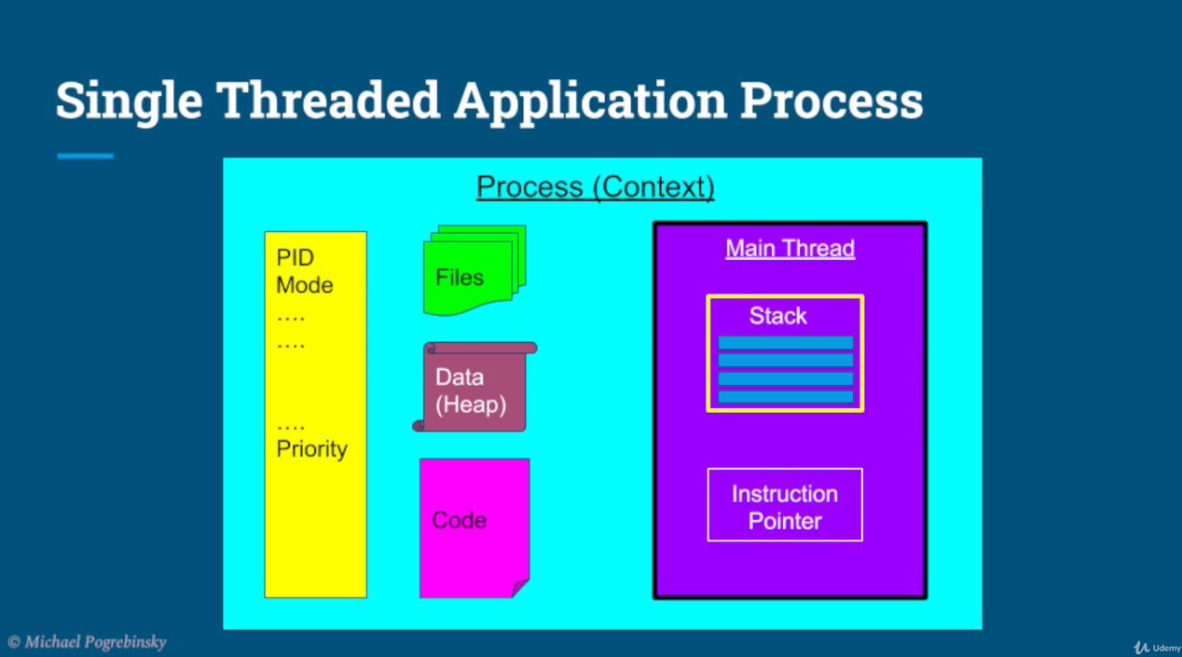

The thread contains two main things, the stack and the instruction pointer.

In a multithreaded application, each thread comes with its own stack and its own instruction pointer, but all the rest of the components in the process are shared by all threads.

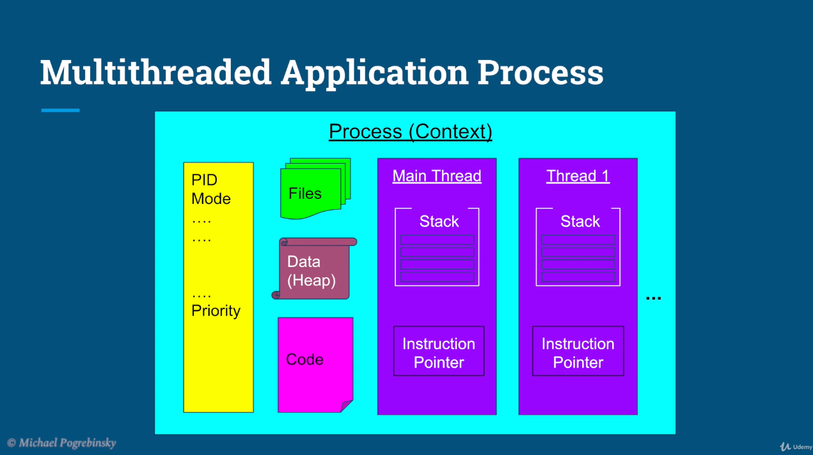

The stack is a region in memory where the local variables are stored and functions are executed.

And the instruction pointer is nothing more than a pointer that points to the address of the next instruction that the thread is going to execute.

